**PRS - Prepaid Reporting System (PRS)** is the prepaid data warehouse used in T Mobile. PRS is getting subscriber information of T mobile customers which can be uniquely identified with subscriber id (sub_id). It has various sources like PAG, NCS, Samson, SAP, Centivia, EPSI, TCP, Serialization, CCPC etc., which will give data as files. Business rules are applied for this data and validated to generate reports.

From source files data which are present in the NFSMount will be taken to landing database PAG5 using shell scripts and procedures. SQLADM is the database where business rules are applied. After applying business rules and cleansing data will be validated. In staging, all reference/ dimensional tables are kept in PAG1 and PAG2.

For events like call, data, data usage data coming is huge. Due to this only 2 years of history is maintained for these events. This will be partitioned with year and month information. For example EventCall, only current month data will be there in table EventCall. And 2 nd of every month data will be moved to corresponding partition named EventCallYYYYMM. There are 2 databases in production, Prod1 and Prod2. Both are replica of each other. Jobs will be running parallel. Two servers are maintained because if one of the servers is down then other can be utilized, so that work won’t get affected.

Now cube will be created processed by taking data from Prod1/Prod2. This is truncate and load. Process type can be given as Full load/ incremental load/ default. The cubes in 01 and 02 OLAP boxes are different. From the cube, Report Info will pull data to load the reports.

System has 5 jobs in total which will take care of execution of all procedures. JobCheck is the job which will be checking the execution of previous Day and will execute current days job only when everything is successful yesterday and this job can be found Job activity monitor of SSMS. JobDailyProc1-4 will be running parallel to execute all the procedures in the required execution order mentioned in tblADMProc, tblADMProcGroup, tblADMProcGroupDepandant tables. Job will not run the procedure if procedure has dependency on some other procedure/ group which is not completed yet.

tbladmServer : - table which is used to keep files and its location with ServerID.

tbladmProc :- This table will give lists of procedures executed successfully, executed and error out, and still executing. It has a field tintProcStatus which holds 3 values – 0/1/2. 0 – Ready for execution, 1 – Executing/ Error out, 2 – Successfully completed.

tbladmProcGroup :- It has files with its group name. Files from same source are grouped together.

tbladmProcGroupDependent – It gives an idea of group dependency. If dependency column is null then that group is not dependent on anything. If a group is dependent of some other group then dependent group has to be executed first.

tbladmTextFile :- It stores all source files with its ServerID. The field bitEnabled will contain 0/1 as data. If it is 0 it is not enabled. If it is 1 it is enabled for execution. It also stores information about field terminator, record terminator, maximum errors, how many days file will be stored etc as columns.

**Smart Mart - SmartMart is Rate Plan driven Reporting System. -** SmartMart is a primary source of Business Intelligence used by the enterprise to track Accounting, Financial Data analysis, sales activity for rate plans and features. The two groups which drive the majority of the functionality within the system are the Sales team and Revenue Accounting. Regional Marketing team also uses SmartMart data for Store and Sales Performance analysis. SmartMart also acts as a data source for other enterprise initiatives, particularly the sales commission’s processes. SmartMart also provides internal business groups reporting on subscriber counts i.e., activations, de-activations, reactivations, migrations and contract renewals. SmartMart tracks all money in and money out related activities in the Postpaid system.

SmartMart is loaded on daily basis hence considered to be more accurate than EDW which is refreshed thrice in a week. It has accuracy ratio of 95% when compared to EDW which is 80%. EDW stores data related to post-paid like usage information, device information etc. Basically, SmartMart is a subset of EDW.

Smart Mart is a postpaid billing system which is used to keep track of accounting, financial dataanalysis, sales activity etc. It also gives report on subscriber activity. Mainly there are 3 sourcesfor smart mart system – OSR, SAP BW &amp; SQLDIM.

Data will be moved to landing area NFSMOUNT Landing area which is nothing but Staging DB from the files available in NFS Mount. From Staging landing (Call it staging DB because it can confuse you with Landing DB of PRS) area by using ETL, data will be moved to staging. Then it will be cleansed and validated. Required changes and business rules will be applied and then the data is moved to SM_FACT and SM_DIM databases. From fact and dimension database data will go to Gemini database which contains only views but no tables. From Gemini SSAS cubes will be built and it Report Info will make reports out of SSAS cubes.

Gemini database contains only 2 months of data. Fact will store 12 months of history.

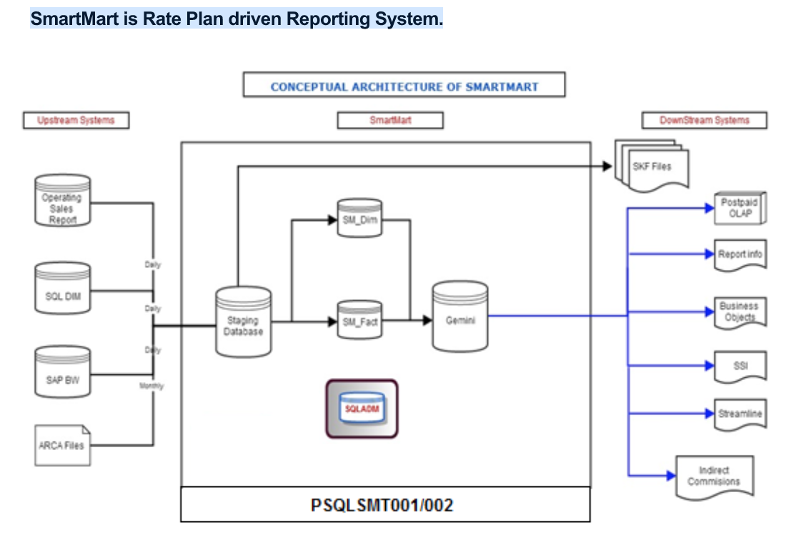

Cognizant – KBM My role

MR - The Membership Repository (MR) was created as a Health Net One System project in 2003 to support the NE claims system.  It is a database of group, benefit and member data containing both demographic and timeline-oriented information.  From the beginning and moving forward the MR has been an evolving database housing an ever-increasing number of data fields to be used by downstream applications and by providing extracts of the data to other systems and vendors.

MR consolidates the member information from four legacy systems: ABS, MC400, CSC and InStil. To the Outbound Interface systems, both internal and external to Health Net, it serves as a means to retrieve accurate and secure membership information.

KBM--

Knowledge Base Marketing is a third party vendor for Health Net. It provides Marketing solutions. MR sends Member Eligibility information to KBM. The purpose of the KBM database is to house member information, prospective members from rental lists, response data for promotions, and generate lists (mailing & telemarketing) and reports.

•             Source data will be uploaded from the ABS,CSC and MC400 systems into the Membership Repository and then transmitted to KBM.

•             The Health Net Data Warehouse may be an alternate data source to KBM.

•             Exchange of files between Health Net and KBM will be completed using a secure, electronic protocol.  Method to be determined by EFT team based on KBM capabilities and cost considerations.

•             Finally COPY the Support files to FTPPRD Library for EFT scripts processing

•             To identify the member related information these look up tables are copied.

Transmission Cycles:

Full Eligibility files will be sent weekly to KBM, on Thursday PM - Friday AM at the end of the day.   This will allow KBM to confirm receipt and use the weekend for processing.

File Transmission:

Full eligibility files will be created on a weekly basis and will be FTP’d from Health Net every Friday morning to KBM.  The files will be sent via an agreed upon encryption protocol.  HN EFT Team will coordinate the setup of file naming conventions and method of transmission to KBM.

Knowledge Base Marketing’s FTP server is a closed/secure server, no anonymous logins are accepted.  Each user must have a unique ID and Password.

Retail Project – ETL informatica

regarding a retail project information, the best way for you to find out all the information you need is to look into the workflows/mappings which comprise the ETL process that you are supporting. Look at the data stored in the tables that are used as Sources and Targets within the Informatica Mappings and understand the data by profiling it, as an example - how is an Order data stored. Trace from Source/s through Target/s. There are a lot of areas where Informatica ETL processes are used in an organization.

What happens in retail world like a Nike store?

In a retail setup, you either have brick and mortar stores - real stores in malls, and also there is an e-commerce setup for all stores these days and Nike has presence both ways.

What happens in the stores?

A customer goes to the store and purchases a product like Nike shoes, clothes, sports goods, etc.

What happens via the ecommerce?

It is a little different in the way that business is conducted via ecommerce. User/s log onto the ecommerce site, that is Nike's web store as an example, and place orders for the goods they are interested in purchasing. In this process, a user will ADD the items to his CART. Once he is done adding all items he wants to purchase, he places an ORDER by furnishing his credit/debit card details. User gets a confirmation with the ORDER NUMBER and other information via EMAIL. The ORDER goes through the FULFILLMENT process and WHEN the ORDER is SHIPPED, ONLY THEN THE CREDIT/DEBIT CARD IS CHARGED. Shipment confirmation is emailed. All the above information is captured in various databases and tables.

What happens when customers make a purchase?

If a customer purchases a product in a store, he will pay for it at the POINT OF SALE terminal and the purchase or TRANSACTION or SALE IS COMPLETE.

This data is now at an individual store. The company will have many stores around the world. Data from all the stores around the world is collected for analysis and reporting on a daily basis, or if required at shorter intervals too.

What happens next?

All the information or data around the customers shopping exercise, ie.,when a customer actually purchases goods at the store are now recorded or captured in the OLTP systems. What it means by capturing the data in OLTP system means, the order information for the goods purchased by the customer is logged into the order database/tables.

All this order information needs to stored into the Data Warehouse on a daily basis in order to collect sales or order data in order to maintain history for analysis later on and for running financial reports. Storing historical data helps the company's management or executive team to see an individual stores' performance or the company's performance as a whole. For example, Year or Year sales comparison at individual store level, quarterly performance, etc. Another use of this data will help with replinishing stocks, make promotions on certain items that are not selling well, adjusting the prices on goods, etc.

What NEXT?

All the data from the above order (and return) processes is always captured in a relational database. This is a complex process in itself. You get data from various sources in various formats and at various frequencies and granularities. All this data needs to be processed to be able to load into the Data Warehouse which is where we use ETL tools like Informatica, Ab Initio, DataStage, etc.

Best of Luck!

Sridhar

NOTE: Don't be discouraged when people do not give answers you want or look for. Real world it is. You get a lot of free advice like "Don't lie". I DO NOT ENCOURAGE TELLING LIES. However, instead of giving such free advise, they could have written a few sentences about retail process. They forget that were not born with retail experience. Damn!